SyncSharp: Plug & Sync

File Synchronization Software

User Guide V2.1

***7/21/2010***

***Azhar Bin Mohamed Yasin***

***Loh Jianxiong Christopher***

***Hong Lei***

***Guo Jiayuan***

***Tian Shuang***

***Tan Yewkang***

**TABLE OF CONTENTS**

[Part 1: Product Description 3](#_Toc258893231)

[Part 2: Using Syncsharp 3](#_Toc258893232)

[2.1 On First Run 3](#_Toc258893233)

[2.2 Creating New Sync Task 4](#_Toc258893234)

[2.3 Delete Sync Task 5](#_Toc258893235)

[2.4 Task Management Menu 6](#_Toc258893236)

[2.5 Modify Sync Task 7](#_Toc258893237)

[2.6 View Log 12](#_Toc258893238)

[2.7 Import Profile 13](#_Toc258893239)

[2.8 Export Profile 15](#_Toc258893240)

[2.9 Analyze SyncTask 17](#_Toc258893241)

[2.10 PlugSync 19](#_Toc258893242)

[2.11 Configuring Global Settings 20](#_Toc258893243)

[Part 3 Troubleshooting 21](#_Toc258893244)

[3.1 Auto-Play feature Is Not Working 21](#_Toc258893245)

[Part 4 Glossary 23](#_Toc258893246)

# Part 1: Product Description

Syncsharp is developed for users who work with multiple computers and need to synchronize files that reside in different computers through an immediate device such as a USB drive. It is a Windows-based application that allows users to sync files between multiple computers through an intermediate device and requires no installation. The file synchronization process is streamlined through a list of pre-determined user preferences.

# Part 2: Using Syncsharp

## 2.1 On First Run

On first run, the user has to manually double click the SyncSharp executable. For subsequent runs, the program will launch automatically upon USB device plug-in. When SyncSharp launches, the following window (main window) will pop up.

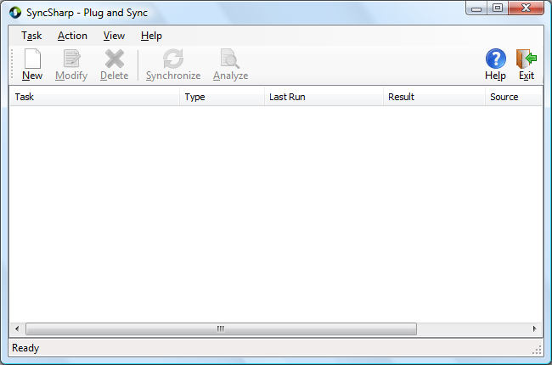

## 2.2 Creating New Sync Task

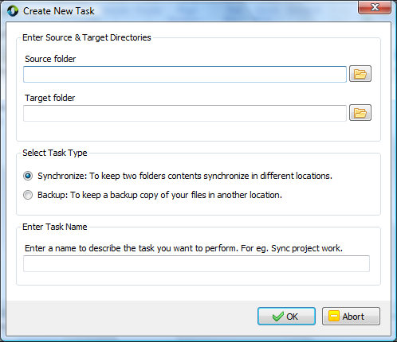

*Step 1:* Click on ***New***, the ***Create New Task*** window will show up.

*Step 2:* Click on the browse icon  to select the source and target folders. Alternatively, user can type the directory into the text box. (Environment variables like %HOMEPATH% in the path name.)

*Step 3:* ***Select Task Type***.

Synchronize – To keep source and target folders contents in sync.

Backup – To backup files in source folder to target folder.

*Step 4:* ***Enter Task Name***. Specify the name of this Sync Task.

*Step 5:* Click on ***OK*** to finish.

Alternatively, users can drag and drop folders into the main window and the folder paths will automatically displayed in the **Create Task Form** window.

## 2.3 Delete Sync Task

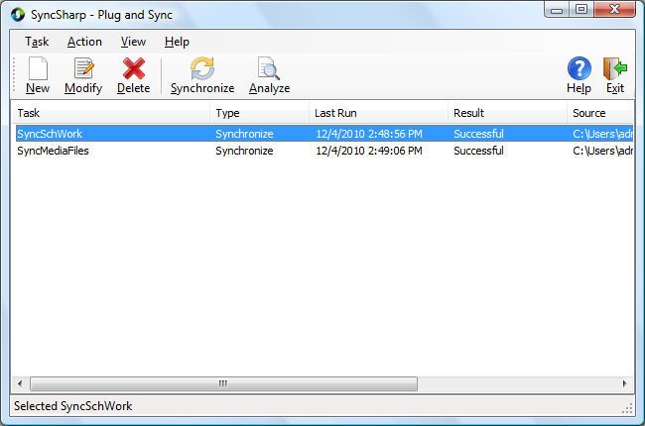

*Step 1:* Choose the Sync Task you want to delete.

*Step 2:* Click ***Delete***.

*Step 3:* A confirmation dialog will pop up, click *Yes* to confirm deletion or click *No* to cancel.

## 2.4 Task Management Menu

On the main window, right clicking on any task will bring up a ***context menu*** (as shown below). The user can modify, delete, rename, synchronize, view log file or create a new task using the menu.

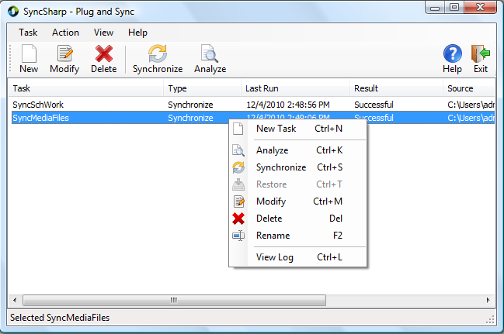

|  |  |
| --- | --- |
|  | **New Task**: Create a New Task  **Analyze**: Preview a synchronization task  **Synchronize**: Sync the selected task  **Restore**: Restore a previously backup task  **Modify**: Configure task settings  **Delete**: Remove the selected task from profile  **Rename**: Rename the selected task  **View Log**: Display the log file of the task |

## 2.5 Modify Sync Task

*Step 1:* Select a task and click ***Modify*** (or just double-click on the task). The ***Task Setup*** window which consists of the following four tab pages will pop up.

***General*** Tab

This tab page display general information on the sync task. The user can rename the task and change the task type in this tab page.

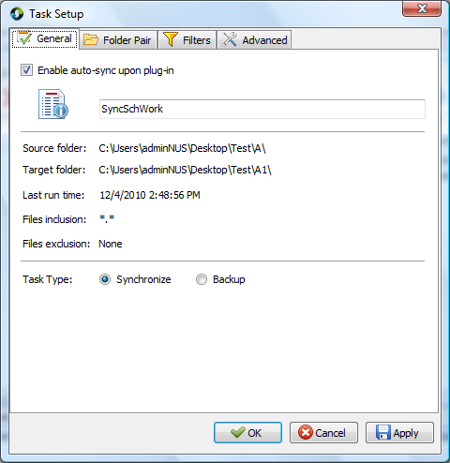

***Enable auto-sync upon plug-in*** – With this option checked, the task will run automatically when the program is executed again.

***Folder Pair*** Tab

The user can change the source and target directories in this tab page.

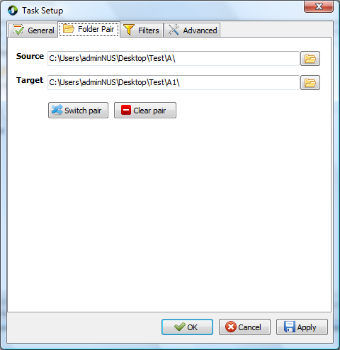

***Switch pair*** – Switch the “Source” and “Target” paths

***Clear pair*** – Delete the “Source” and “Target” paths

***Filters*** Tab

The user can set filters for the files and folders in this tab page.

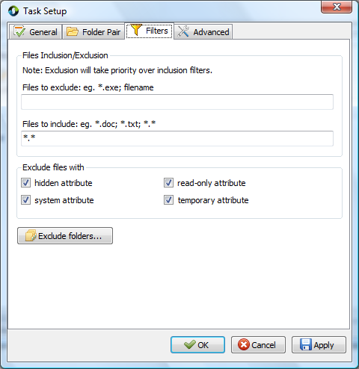

***File Inclusion/Exclusion*** - Users are allowed to include/exclude files in the “source” and “target” directories of the sync process. Filtering is based on file name or extension, (For e.g., to exclude all files with extension ‘***.doc***’, enter ‘***\*.doc***’ in the ‘***Files to exclude***’ textbox). The user is allowed to set multiple filtering criteria by separating them with a ‘***;***’.

Filtering of subfolders is achieved through the ***Exclude folder…*** option***.***

***Exclude files with*** – Filtering can also be achieved based on the attributes of the files or folders. The default files to exclude are files with the ‘***system***’ and ‘***temporary***’ attribute.

***Exclude folders…*** will list out all subfolders from “Source” and “Target”. The user can exclude subfolders by checking the respective folders. (Below is a screenshot of the Exclude Subfolders window).

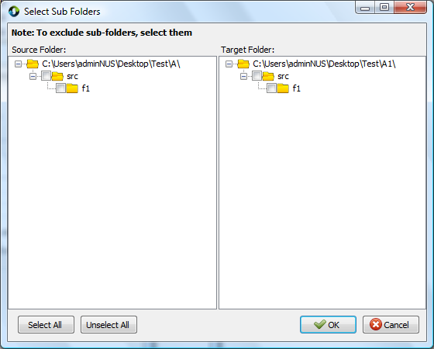

***Advanced*** Tab

The user can configure file conflict settings in this tab page.

**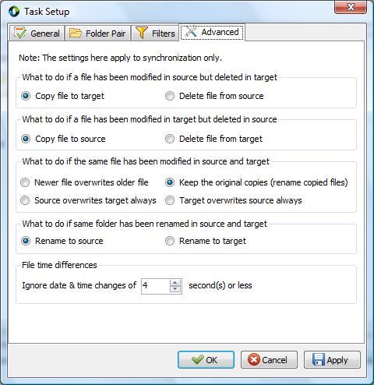**

***File time differences*** – While comparing two files or folders, if the difference in last-modified-time is less than or equal to the pre-set value in this tab page, these files or folders are considered to be similar.

## 2.6 View Log

***View Log*** provides a summary on the last synchronization to user. File operations like copy/delete/move are recorded in a log file. A sample log file is shown below.

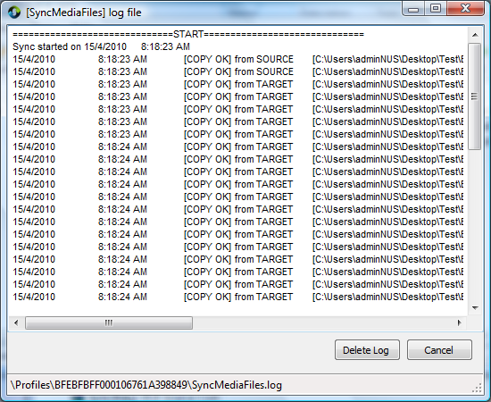

***Cancel:*** Close the View Log window

***Delete Log:*** Delete the task’s log file from the disk

## 2.7 Import Profile

*Step 1*: On the main menu, click on ***Task***

*Step 2*: Click ***Import Profile …*** or simply use ***Ctrl + I***

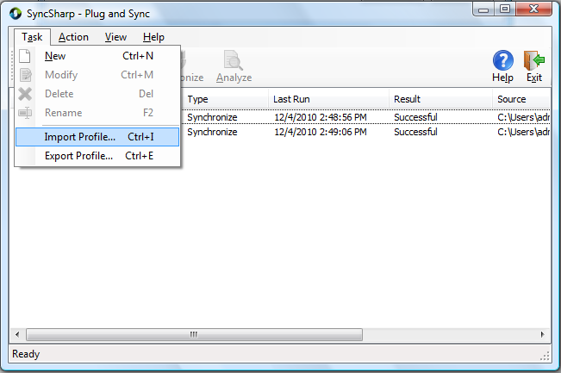

*Step 3*: Specify which Profile to import.

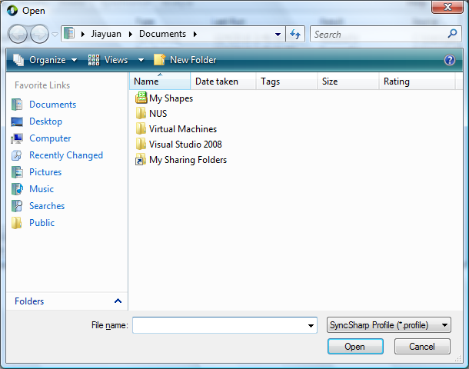

## 2.8 Export Profile

*Step1*: On the main menu, click on ***Task***

*Step 2*: Click ***Export Profile …*** or simply use ***Ctrl + E***

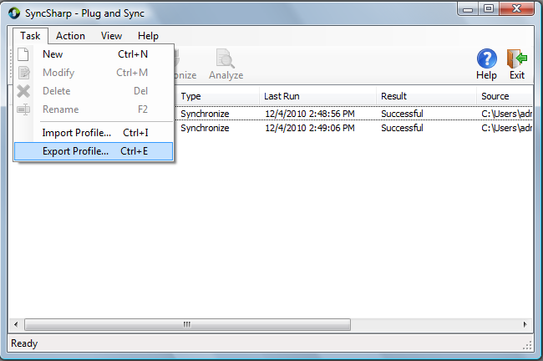

*Step 3*: Specify the location you want the Profile to be saved.

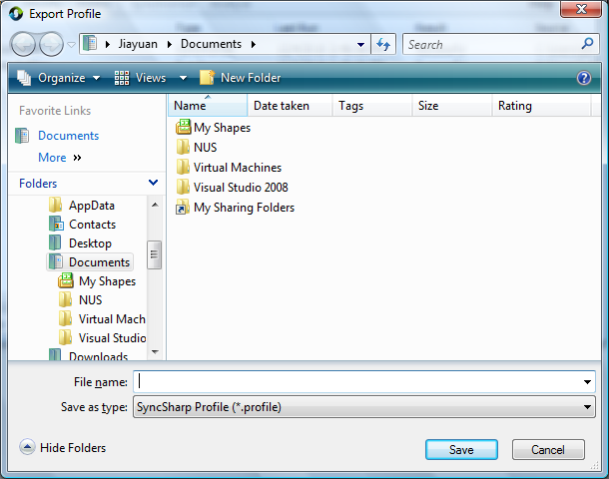

## 2.9 Analyze SyncTask

The user can analyze a **sync task** by simply clicking the Analyze button on the main window or by entering ***Ctrl+K.*** The following window will be displayed when the Analyze button is clicked.

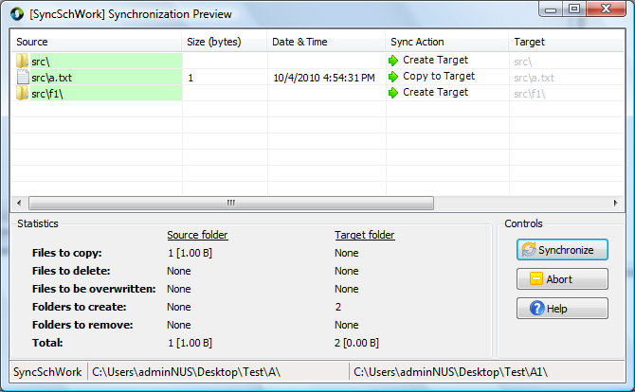

The following table lists out the possible icons that could be displayed in the **Sync Action** column along with its description.

|  |  |
| --- | --- |
| Icon | Description |
| C:\Users\adminNUS\Desktop\SyncSharp V1.1\Project Icons\left_copy.png | Copy file to source/Create Target folder |
| C:\Users\adminNUS\Desktop\SyncSharp V1.1\Project Icons\right_copy.png | Copy file to target/Create Source folder |
| C:\Users\adminNUS\Desktop\SyncSharp V1.1\Project Icons\KeepBoth_small.png | Keep both files in source & target folders |
| C:\Users\adminNUS\Desktop\SyncSharp V1.1\Project Icons\delete_small.png | Delete both files/folders |
| C:\Users\adminNUS\Desktop\SyncSharp V1.1\Project Icons\delete_left.png | Delete source file/folder |
| C:\Users\adminNUS\Desktop\SyncSharp V1.1\Project Icons\delete_right.png | Delete target file/folder |
| C:\Users\adminNUS\Desktop\SyncSharp V1.1\Project Icons\rename_small.png | Rename source/target file |

Moreover, the user can right-click on one of the items to access a list of commands as show in the following screen shot

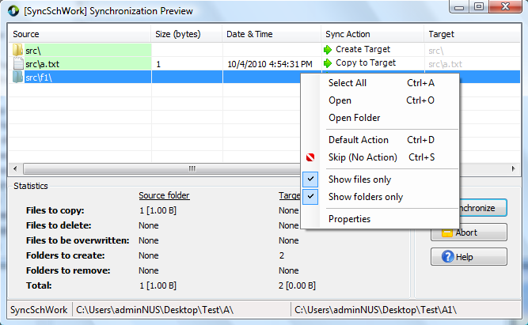

|  |  |
| --- | --- |
|  | **Select All**: Select all items in list  **Open**: Open the selected item  **Open folder**: Open the item’s parent folder  **Default Action**: Change to default sync action set by the system  **Skip (No Action)**: Exclude the selected item from synchronization  **Show files only**: Display files only  **Show folders only**: Display folders only  **Properties**: Display info about the selected item |

The user can click on the button to proceed with synchronization or click the  button to return to main window.

## 2.10 PlugSync

After the user has set up the tasks (with auto-sync enabled) in Syncsharp, the **PlugSync** window (as shown below) will be displayed when the program is launched. It will start a countdown of five seconds (default) before synchronizing all tasks listed in the window.

The user can return to main window by clicking on the  button. Moreover, the user can re-order the tasks in the synchronization queue by clicking the up  and down buttons. The user can also remove a task by clicking on the  button if the task has not undergone synchronization yet.

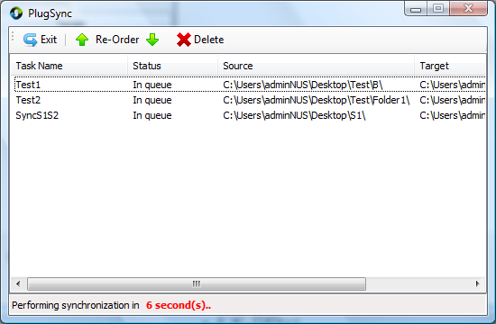

## 2.11 Configuring Global Settings

*Step1*: On the main menu, click ***View***

*Step 2*: Click on ***Options …***, the ***Global Settings*** window shown below will pop up

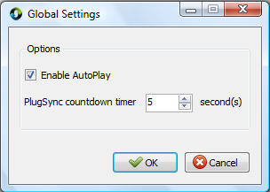

*Step 3*: Use the up and down arrow to change the default countdown timer. (Sync will start right away if the timer was set to 0.)

***Enable AutoPlay.*** If checked, an ***autorun.inf*** file will be created on the external storage device to instruct it to launch SyncSharp once the USB device has been plugged into the PC.

# Part 3 Troubleshooting

Warning: When synchronizing files to a USB device, please DO NOT unplug your USB device. It may result in unexpected behavior corrupted files.

## 3.1 Auto-Play feature Is Not Working

On some Windows machines, the ***auto play*** feature may be disabled. In order to fully automate the synchronization process using ***PlugSync***, the user may need to modify the ***auto play*** settings. This guide will walk you through changing the ‘auto play’ settings.

On Windows Vista:

*Step 1*: Click on ***Start*** 🡪 In the search box, type in ***autoplay***

*Step 2*: Choose the first returned result, which looks like



*Step 3*: Click on the icon and the following window will pop up.

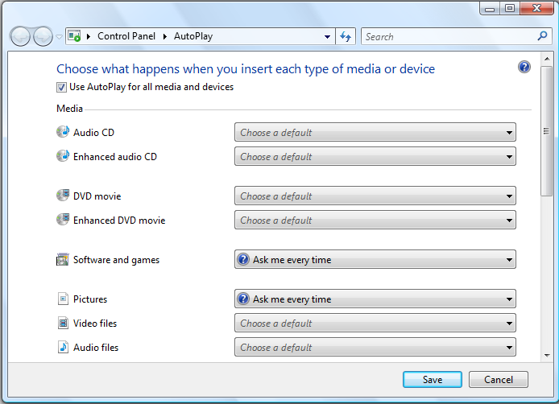

*Step 4*: Check the box ***Use AutoPlay for all media and devices***

*Step 5*: In the drop-down list for ***Software and games***, choose ***Ask me every time***.

*Step 6*: Click on ‘***Save***’ to save the setting.

*Step 7*: The next time the user plugs in his external storage device, system will prompt the user. A window that looks like the one below will appear. Check the box ‘***Always do this for software and games:***’ and click on ‘***Run SyncSharp***’ to activate the program. By doing this, this action is saved on the machine, and the PlugSync feature will function properly.

**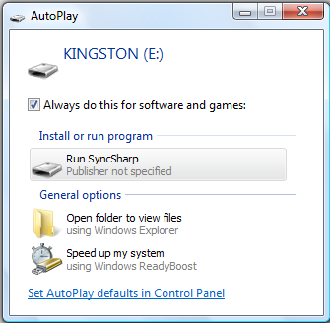**

# Part 4 Glossary

|  |  |
| --- | --- |
| Term | Definition |
| SyncSharp | Name of our sync tool |
| SyncTask | Configuration file used in synchronization that contains information on the source and target directory |
| SyncProfile | Contains list of SyncTasks for a Particular PC/Laptop |
| FileUnit | Abstract representation of a file or folder, contains information such as name, size, hash code, last modified date, etc |
| PlugSync | A feature of our program. Program will synchronize all tasks automatically when the USB device is plugged into a computer. Upon execution, the program will count down for five seconds. If the user did not interrupt the countdown, the program will proceed to synchronize all the tasks listed in the window |
| 1 way sync | Update destination directory so that it holds the contents of the source directory |
| 2 ways sync | Update source and destination directories so that they have the same contents |
| Report/Logger | Log file that records the operations performed during the synchronization process |
| Target | The destination directory of the synchronization process |
| Detector | The sub-system that detect changes to the source or destination directory |
| Reconciler | The sub-system that resolves conflicts between the source & destination directories |
| TaskSettings | Contains configuration settings unique to each SyncTask |